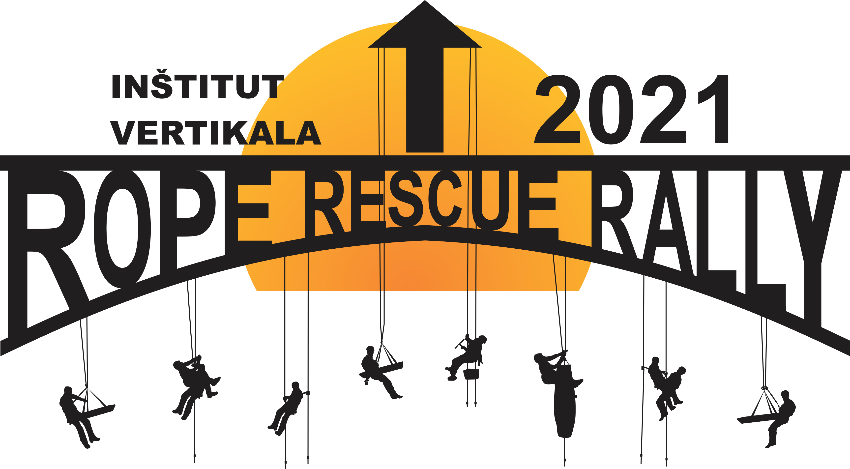
ENTRY FORM
Fill out the entry form (no signature required) and send it to our email address institutvertikala@gmail.com. By doing this you will ensure your position in the list of registered participants. Print out one copy, sign it and send it to our address - Geoprevis, Blaž Bertoncelj s.p., Kunaverjeva ulica 8, 1000 Ljubljana, Slovenia by no later than Jun 27th 2021.

Team - info
Name of team
Organisation
(fire fighters, MRS, CRS, civil protection service etc.)

Contact person - info |  | Participation fee payer (220€+ tax) - info
Name and surname: |  | Name of organisation:
Name of organisation: |  | Address of organisation:
Tel. no.:
E-mail address: |  | Tax ID number:

Team members - info
Function | Name and surname | Date of birth | T-shirt size  (S, M, L, XL, XXL)
Team leader
Team member
Team member
Team member
Driver / logistic specialist

By submitting this form we confirm to be informed about the competition rules and participation conditions and agree to them.

Name and surname of person responsible for team registration
Signature of person responsible for team registration
Place and date

